The Uxbridge Baseball Association (UBA) and Uxbridge Softball Association (USA) are non-profit organizations in the town of Uxbridge, Massachusetts whose mission is to provide an environment for kids that promotes their enjoyment, appreciation, and understanding of the game of baseball and softball.

On Monday, May 21, 2018 9AM Shotgun Start – Blissful Meadows Golf Club, the associations will be jointly hosting a Golf Tournament Fundraiser. Proceeds from the golf tournament will help each organization with ongoing field maintenance, equipment needs, and capital improvement plans. Thank you in advance for supporting our leagues and helping make it possible for the children of Uxbridge to "Play Ball!"

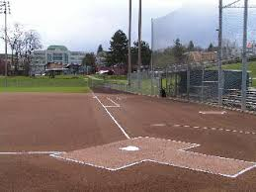

The Golf Tournament is the main fundraising event this year for both UBA & USA. In order for this tournament to be a success, we are in need of golfers, donations and sponsors!

If you would like to participate and golf, contribute or be a sponsor; visit our web site for information and to complete the registration process: https://www.uxbridgebaseball.com/orderitems.php?cid=3

For more information or if you have any questions, please email: golftourney@uxbridgebaseball.com, Also, please go to our website for all other information regarding the Golf Tournament: www.uxbridgebaseball.com.

Please help support the Uxbridge Baseball & Softball Associations!

Thank you,

Uxbridge Baseball Association & Uxbridge Softball Association

